

Penetration Testing Internship
Submitted By | Irsa Attique
Submitted To | DEV SHIELDX
Date | 16/07/2026
Intern ID | DSX-CYB-10
Task | 15(Capstone Project)
Batch | 2

Capstone Project Report
Target Application: Damn Vulnerable Web Application (DVWA)
Assessment Type: Black-Box Web Application Penetration Test
1. Executive Summary:
To identify misconfigurations, flaws and to exploit vulnerabilities, and independent black box security assessment was conductions against DVWA. The assessment adhered strictly to the industry-standard OWASP Web Security Testing Guide (WSTG) methodology.
The security evaluation uncovered critical vulnerabilities that allow complete underlying system compromise and unauthorized data extraction. Notably, Remote Code Execution (RCE) via Command Injection was verified, alongside Database Credential Disclosure via SQL Injection. Additionally, severe administrative directory listings, lack of defensive HTTP headers, and exposed sub-version control files were discovered.
Immediate code-level remediation is required to secure the target application against real-world unauthorized access and operational disruptions.
2. Objective:
The objective of this task was to:
- Gain access to the application’s posture from an external threat perspective.
- Enumerate crawl directories, enumerate services and physically validate security flaws without disrupting service availability.
- Gauge the severity of validated findings using the Common Vulnerability Scoring System (CVSS v3.1).
- Outline precise, programmatic steps to patch and protect the target application code from exploitation.
3. Scope:
The security assessment was bounded to the local deployment instance of the DVWA environment:
- Target URL: http://localhost/DVWA/
- Target IP Address: 127.0.0.1 (Localhost)
- Testing Modality: Black-Box Testing.
- Constraints: Active exploits were executed exclusively against the self-hosted, authorized lab environment to maintain strict compliance and prevent lateral real-world impacts.
4. Methodology:
Standardized phases of the OWASP Web Security Testing Guide (WSTG) were followed during the assessment which utilized an organized five-stage lifecycle:
- Reconnaissance: Active footprinting of the target server, identifying open ports, active services, and technology signatures using “WhatWeb and Nmap”.
- (Enumeration): Spidering and directory-busting using “FFUF and Nmap NSE” scripts to discover exposed directories, hidden administrative endpoints, and orphaned source control configurations.
- Vulnerability Assessment: Analyzing structural weaknesses and identifying missing secure headers or weak platform parameters using “Nikto”.
- Exploitation: Executing proof-of-concept (PoC) payloads targeting Command Injection and SQL Injection endpoints, demonstrating the real-world impact of the flaws.
- Reporting & Remediation: Documenting all technical findings, calculating CVSS impact, and outlining exact patch instructions for stakeholders.
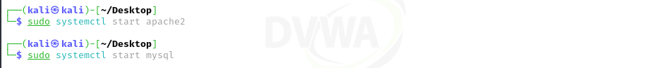
5. Environment Setup:

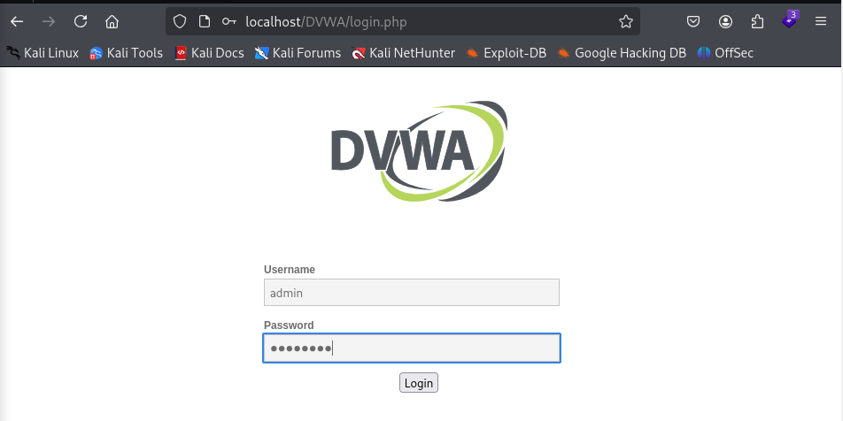
(Initiating Apache and MySQL system services in the Kali Linux environment.)

(Navigating to the local DVWA landing login page.)
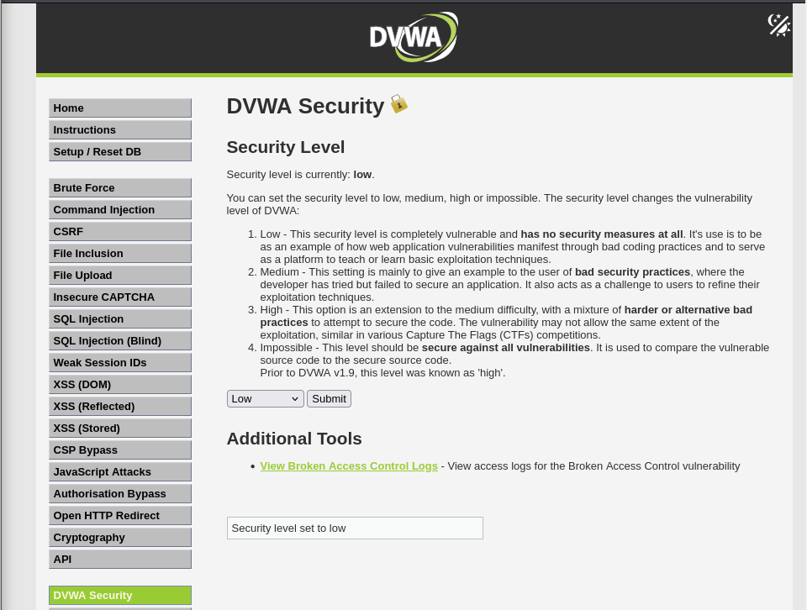

(Setting the target testing baseline security setting to 'low'.)
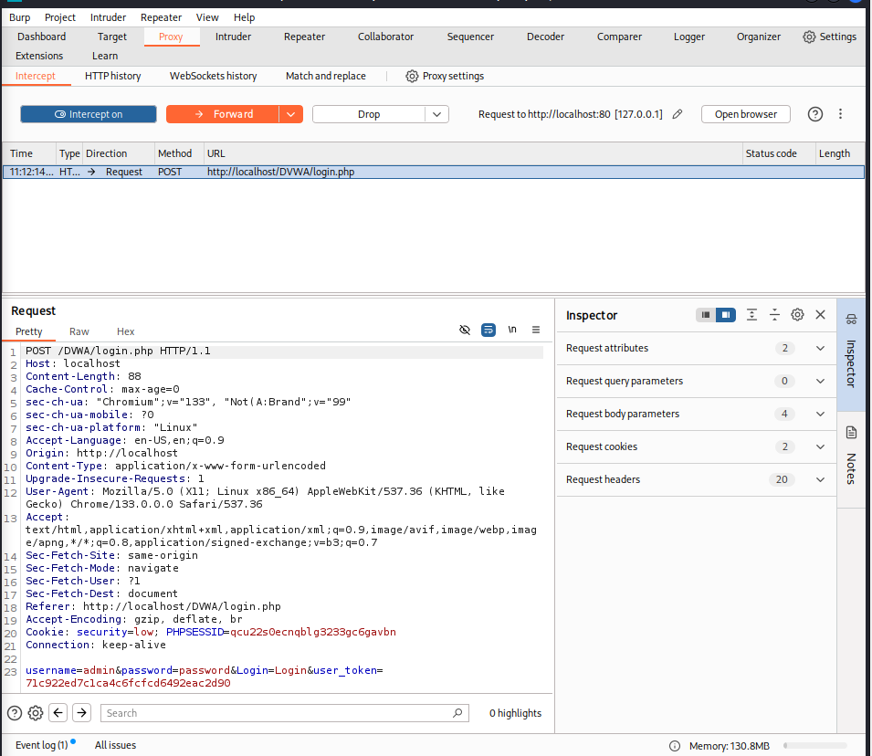

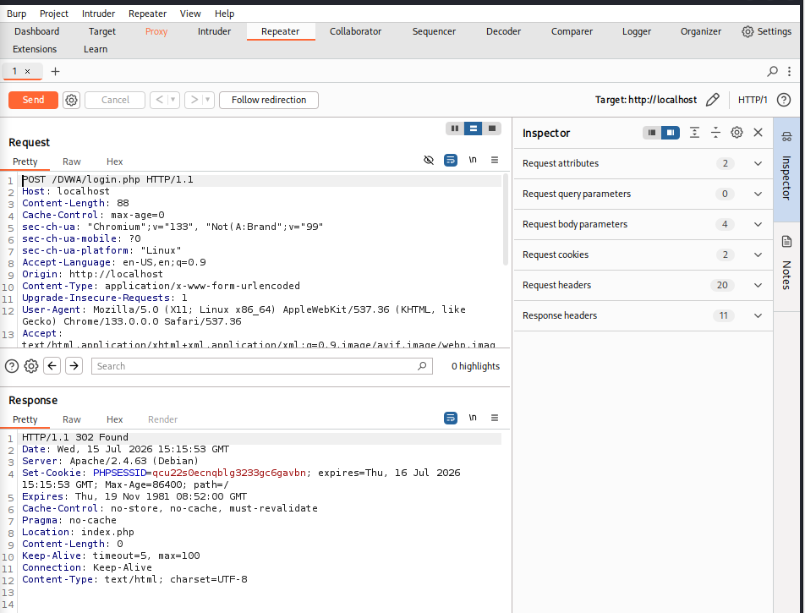
(Capturing raw authentication POST parameters and CSRF tokens using the Burp Suite Intercept proxy.)

(Analyzing request authentication flow and the redirect response status code using Burp Suite Repeater.)
6. Target Information:
Baseline technology footprinting was performed using the whatweb CLI utility to determine the server configuration and underlying technologies.
Fingerprinting Signature Output (whatweb http://localhost/DVWA/login.php)
- Target Endpoint: http://localhost/DVWA/login.php
- HTTP Status Code: 200 OK
- Web Server: Apache HTTP Server version 2.4.63 (Debian)
- Operating System Platform: Debian Linux
- Session Cookie Engine: PHPSESSID
- Authentication/Security Parameter: security cookie parameter tracking active security levels.
- Markup/Interactivity: HTML5 compliant webpage with input password fields.

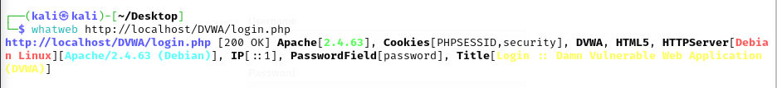

(Target technology footprinting signature output using WhatWeb)
7. Reconnaissance Findings:
Nmap was used for active scanning which helped to map accessible transport layers and services listening on the target.
Port and Service Scan (nmap -sV -p 80,3306 localhost)
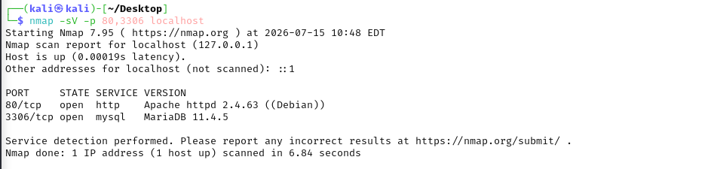
The system runs a LAMP/WAMP equivalent environment. Port 80 handles public web traffic, and Port 3306 hosts the backend MariaDB database. Because Port 3306 is open, it represents a potential vector for direct database connectivity attacks if firewalling is inadequate.

(Nmap service scanning confirming open ports 80 (HTTP) and 3306 (MySQL).)
Passive Directory Enumeration (nmap --script http-enum localhost)
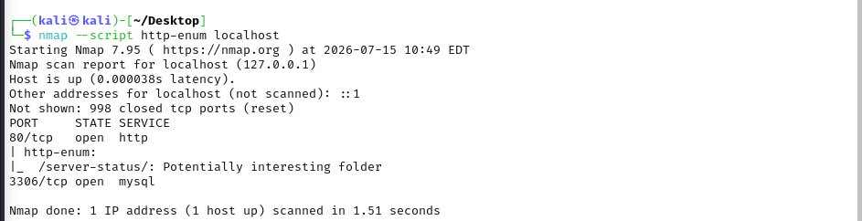
The administrative /server-status/ folder is exposed. This directory can leak active client IP addresses, request URIs, and server load metrics to unauthenticated users.

(Passive directory enumeration script revealing sensitive system directories.)
8. Vulnerability Assessment:
An automated vulnerability scan using Nikto combined with directory fuzzing via FFUF revealed massive structural flaws in the host configuration.
Automated Vulnerability:
- Missing Anti-Clickjacking Header: X-Frame-Options is not set, exposing users to frame-based UI redressing attacks.
- Missing MIME Sniffing Mitigation: X-Content-Type-Options is not set, allowing browsers to interpret responses away from the declared content-type.
- Insecure Cookie Flags: Session cookies (PHPSESSID) are set without the HTTP Only flag, making them extractable via Cross-Site Scripting (XSS).
- Information Leakage via Directory Indexing:
  - /DVWA/config/ (Configuration files accessible)
  - /DVWA/database/ (Database storage schemas exposed)
  - /DVWA/docs/ (System documentation accessible)
  - /DVWA/tests/ (Test files available)
- Exposed Git Repositories:
  - /DVWA/. git/index
  - /DVWA/. git/HEAD
  - /DVWA/. git/config
  - /DVWA/. git/gitignore
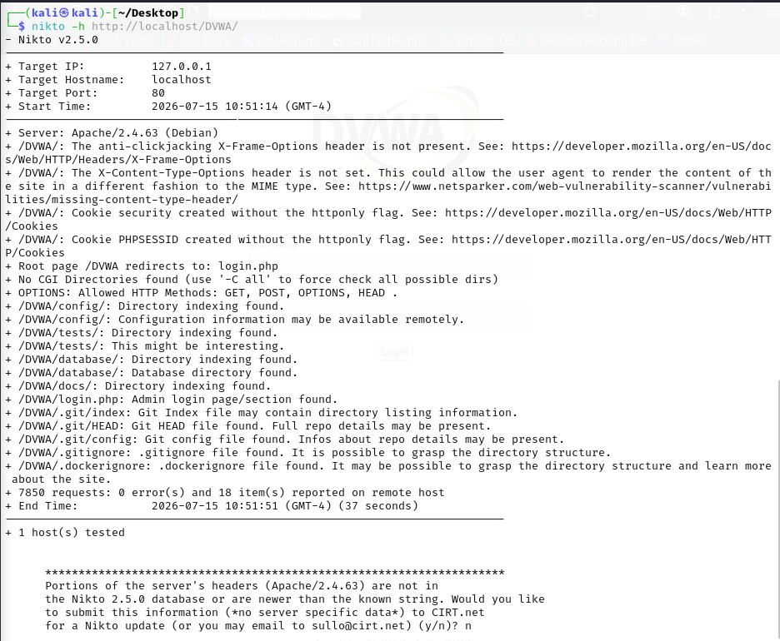

Directory Fuzzing Analysis:
A directory search confirmed the open indexing paths found by Nikto:
Heading | Status, Size
. git/HEAD | [Status: 200, Size: 23]
config | [Status: 301, Size: 312]
database | [Status: 301, Size: 314]
docs | [Status: 301, Size: 310]
php.ini | [Status: 200, Size: 154]
robots.txt | [Status: 200, Size: 25]

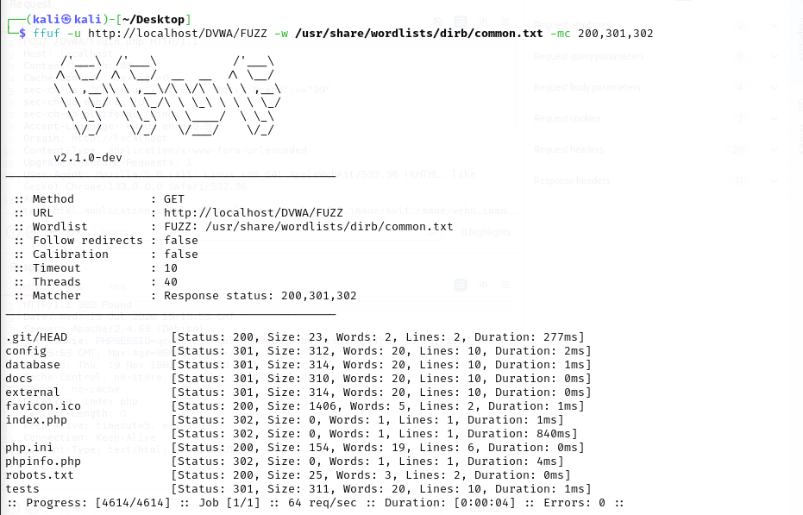
Exposed. git structures allow an attacker to reconstruct the entire application source code locally, uncovering hardcoded database credentials, private API endpoints, and business logic flaws.

(FFUF directory fuzzing confirming directory exposure and sensitive file paths.)
9. Exploitation Results:
The vulnerabilities discovered during the assessment were manually exploited to prove the risk of system compromise.
Vulnerability 1: Remote Code Execution (RCE) via OS Command Injection
- Vulnerable Endpoint: http://localhost/DVWA/vulnerabilities/exec/
- Injection Parameter: ip
- Vulnerability Description: The application concatenates user-supplied input into a shell execution context without sanitizing or escaping system shell metacharacters.
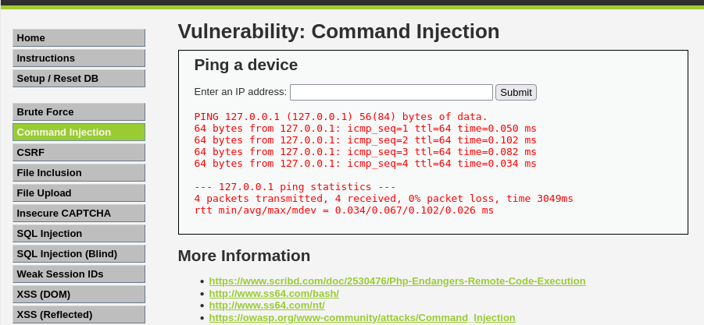
- Exploitation Vector: Inputting 127.0.0.1 && whoami causes the system to run the initial ping command followed immediately by the system shell command whoami.

(Baseline test validating standard ping functionality on the Command Injection target page.)
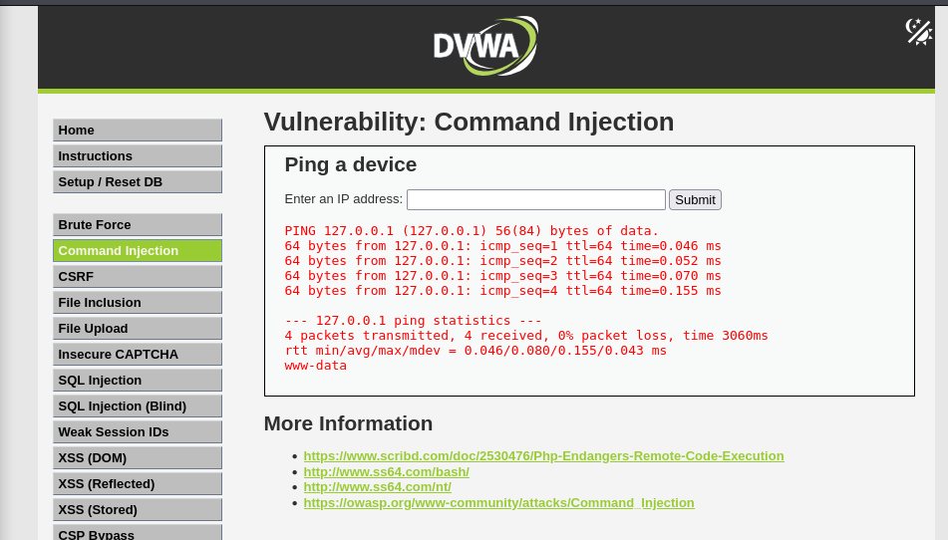
- Validated Impact: The application successfully executed the payload and returned www-data in the HTTP response. This confirms that the web application possesses shell execution privileges, enabling complete host takeover.

Vulnerability 2: Database Credential Disclosure via SQL Injection
- Vulnerable Endpoint: http://localhost/DVWA/vulnerabilities/sqli/
- Injection Parameter: id
- Vulnerability Description: The parameter lacks input parameterization or sanitization, passing raw inputs straight into the SQL interpreter.
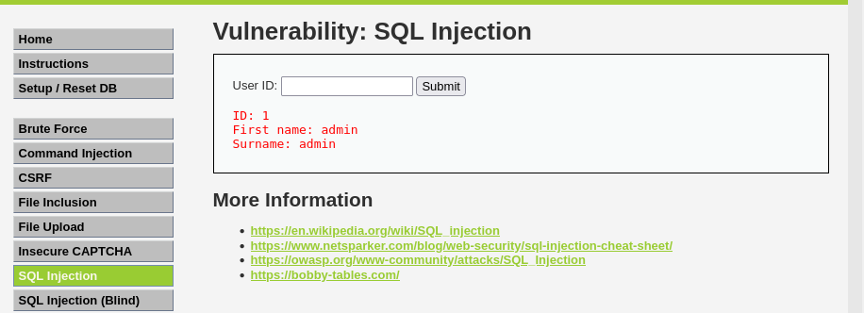
- Exploitation Vector: Utilizing a custom SQL UNION payload: 1' UNION SELECT user, password FROM users#

(Baseline query validation using ID '1' on the SQL Injection target page.)
- Validated Impact: The backend database executed the query, dumping usernames and their corresponding MD5 password hashes directly onto the page:
  - admin: 5f4dcc3b5aa765d61d8327deb882cf99 (Decodes to password)
  - gordonb: e99a18c428cb38d5f260853678922e03 (Decodes to abc123)
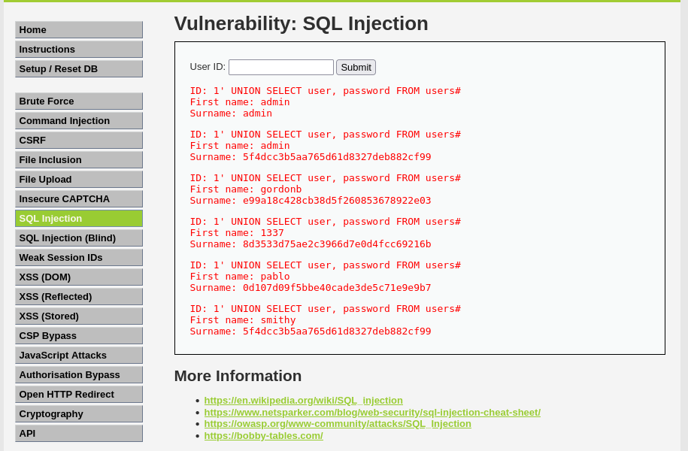
  - 1337: 8d3533d75ae2c3966d7e0d4fcc69216b (Decodes to charley)

10. RISK RATINGS (CVSS v3.1):
Below is the risk rating breakdown based on the verified severity of the findings:
1. Remote Code Execution (Command Injection)
- CVSS v3.1 Base Score: 9.8 Critical
- Vector String: CVSS:3.1/AV: N/AC: L/PR: N/UI: N/S: U/C:H/I:H/A:H
- Risk Level: Critical
- Justification: Can be exploited remotely over the network with low complexity and no special privileges, resulting in a total loss of confidentiality, integrity, and availability.
2. SQL Injection (Credential Disclosure)
- CVSS v3.1 Base Score: 8.6 High
- Vector String: CVSS:3.1/AV: N/AC: L/PR: N/UI: N/S:C/C:H/I: N/A: N
- Risk Level: High
- Justification: Allows unauthenticated actors to read arbitrary database contents, exposing system-wide administrative passwords and user hashes.
3. Exposed Git Repository & Directory Indexing
- CVSS v3.1 Base Score: 7.5 High
- Vector String: CVSS:3.1/AV: N/AC: L/PR: N/UI: N/S: U/C:H/I: N/A: N
- Risk Level: High
- Justification: Public exposure of. git directories and configurations leak vital infrastructure architecture and application source code.
11. Remediation Recommendations:
Remediation for OS Command Injection (RCE)
- Implementation: Never pass raw user inputs directly into system shells (such as PHP's shell_exec (), exec (), or passthru ()).
- Code Fix: Use built-in APIs instead of system commands, or apply strict character whitelisting to validate inputs.
Remediation for SQL Injection
- Implementation: Always use Parameterized Queries (Prepared Statements) with PDO or MySQLi. This keeps user inputs separated from the SQL execution logic.
Remediation for Directory Listing and Exposed Git Repositories
- Apache Configuration Fix: Disable directory listings by adding the following rule to your global Apache configuration or localized .htaccess file:
  - Options -Indexes
- Git Path Protection: Delete or restrict web permissions on. git folders in production:
- rm -rf /var/www/html/DVWA/. git
Remediation for Missing Security Headers
Add these secure headers inside the main virtual host directory setup file:
- Header set X-Frame-Options "DENY"
- Header set X-Content-Type-Options "nosniff"
- Header edits Set-Cookie ^ (. *) $ "$1; HTTP Only; Secure"
12. Conclusion:
The security assessment of the DVWA revealed that the application has a high-risk profile. The validation of Remote Code Execution and SQL Injection demonstrates that how easily an attacker can extract user database records and execute commands on the underlying host.
Implementing input validation, parameterizing SQL statements, disabling web-accessible directory indices, and securing cookie flags will drastically reduce the application's attack surface and prevent these critical compromises.
13. References:
- OWASP Web Security Testing Guide (WSTG):
https://owasp.org/www-project-web-security-testing-guide/
- CWE-78: Improper Neutralization of Special Elements used in an OS Command (OS Command Injection):
https://cwe.mitre.org/data/definitions/78.html
- CWE-89: Improper Neutralization of Special Elements used in an SQL Command (SQL Injection):
https://cwe.mitre.org/data/definitions/89.html
- CVSS v3.1 Calculator (FIRST):
https://www.first.org/cvss/calculator/3.1

14. Internship Reflection:
My cybersecurity internship with Dev ShieldX has been a defining step in my professional journey. As a female student pursuing a BS in Cyber Security at COMSATS University Islamabad, bridging the gap between theoretical classroom concepts and hands-on laboratory application has been incredibly rewarding.
This capstone project consolidated multiple testing workflows: passive infrastructure fingerprinting, automated vulnerability assessments, directory fuzzing, and manual exploitation. Learning how to capture live HTTP POST requests using Burp Suite, analyze headers, modify parameters in the Repeater, and document vulnerabilities using professional CVSS standards has greatly improved my technical skills.
This experience has built my confidence, and I am excited to apply these skills as I work toward my career goal of serving as a technical officer in the military forces. I am very grateful to the mentors at Dev ShieldX for structuring such a practical and comprehensive internship.

